from keras.preprocessing.image import ImageDataGenerator

train_datagen=ImageDataGenerator(rescale=1./255,shear_range=0.2,zoom_range=0.2,horizontal_ text_dataset=ImageDataGenerator(rescale=1./255)

from tensorflow.keras.preprocessing.image import ImageDataGenerator train_datagen = ImageDataGenerator(rescale= 1./255,horizontal_flip = True,vertical_flip = test_datagen = ImageDataGenerator(rescale= 1./255)

x_train = train_datagen.flow_from_directory("/content/drive",target_size = (64,64),

class_mode = "categorical",batch_size = 24)

Found 12656 images belonging to 4 classes.

x_test = test_datagen.flow_from_directory("/content/drive",target_size = (64,64),

clas

Found 12702 images belonging to 4 classes.

import cv2

img = cv2.imread("/content/drive/MyDrive/AI_IBM/Dataset/TEST_SET/APPLES/n07740461_1191.jpg

img

array([[[174, 188, 207], [173, 187, 206],

[171, 185, 204],

...,

[181, 192, 206],

[180, 192, 204],

[179, 191, 203]],

[[175, 189, 208],

[174, 188, 207],

[174, 188, 207],

...,

[182, 193, 207],

[182, 193, 207],

[181, 193, 205]],

[[178, 192, 211],

[177, 191, 210],

[177, 191, 210],

...,

[184, 195, 209],

[184, 195, 209],

[184, 195, 209]],

...,

[[161, 185, 209],

[164, 188, 212],

[163, 191, 215], ...,

[184, 198, 216],

[186, 200, 218],

[187, 201, 220]],

[[157, 185, 209],

[158, 186, 210],

[156, 187, 210], ...,

[185, 199, 217],

[187, 201, 219],

[187, 201, 220]],

[[154, 186, 209],

[153, 185, 208],

[150, 182, 205],

...,

[187, 199, 217],

[188, 202, 221],

[189, 203, 222]]], dtype=uint8)

img.ndim

3

type(img) numpy.ndarray

img.shape

(256, 256, 3)

img_flag = cv2.imread("/content/drive/MyDrive/AI_IBM/Dataset/TEST_SET/APPLES/n07740461_119

img_flag

array([[[174, 188, 207], [173, 187, 206],

[171, 185, 204], ...,

[181, 192, 206],

[180, 192, 204],

[179, 191, 203]],

[[175, 189, 208],

[174, 188, 207],

[174, 188, 207], ...,

[182, 193, 207],

[182, 193, 207],

[181, 193, 205]],

[[178, 192, 211],

[177, 191, 210],

[177, 191, 210], ...,

[184, 195, 209],

[184, 195, 209],

[184, 195, 209]],

...,

[[161, 185, 209],

[164, 188, 212],

[163, 191, 215], ...,

[184, 198, 216],

[186, 200, 218],

[187, 201, 220]],

[[157, 185, 209],

[158, 186, 210],

[156, 187, 210], ...,

[185, 199, 217],

[187, 201, 219],

[187, 201, 220]],

[[154, 186, 209],

[153, 185, 208],

[150, 182, 205],

...,

[187, 199, 217],

[188, 202, 221],

[189, 203, 222]]], dtype=uint8)

import matplotlib.pyplot as plt

plt.imshow(img)

<matplotlib.image.AxesImage at 0x7fda968014d0>

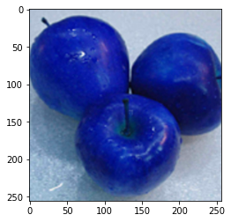

plt.imshow(img_flag)

<matplotlib.image.AxesImage at 0x7fda962e0190>



resized_img = cv2.resize(img,(100,100))

resized_img.shape (100, 100, 3)

plt.imshow(resized_img)

<matplotlib.image.AxesImage at 0x7fda962c7f90>

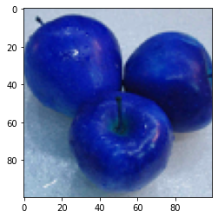

cv_img = cv2.cvtColor(img,cv2.COLOR_BGR2YCR_CB)

plt.imshow(cv_img)

<matplotlib.image.AxesImage at 0x7fda96233810>

plt.imshow(cv_img)

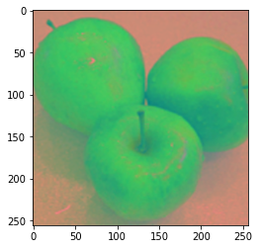

cv_img = cv2.cvtColor

(

img

,

cv2.COLOR_BGR2GRAY

)

<

matplotlib.image.AxesImage at 0x7fda

96218e50>

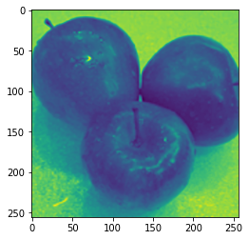

roi_img = img[50:280,35:150] roi_img = img[10:40,35:150]

plt.imshow(roi_img)

<matplotlib.image.AxesImage at 0x7fda961935d0>

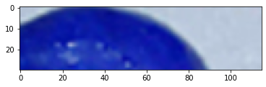

roi_img = img[10:40,0:90]

plt.imshow(roi_img)

<matplotlib.image.AxesImage at 0x7fda960f3610>

plt.imshow(roi_img)

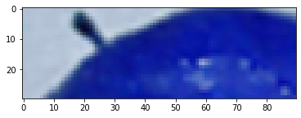

roi_img = img

[

0

:

90

,

10

:

40

]

<

matplotlib.image.AxesImage at 0x7fda9605ac

50>

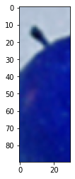

img_bl = cv2.blur(img,(10,10))

plt.imshow(img_bl)

<matplotlib.image.AxesImage at 0x7fda96041b10>

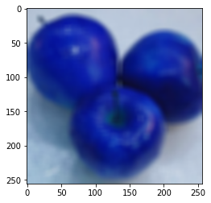

img_gbl = cv2.GaussianBlur(img,(5,5),0)

plt.imshow(img_gbl)

<matplotlib.image.AxesImage at 0x7fda95fb41d0>

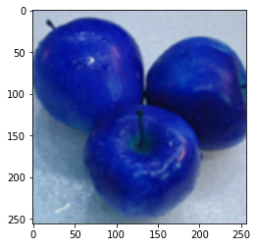

img_edge = cv2.Canny

(

img

,

230

,

350

)

<

matplotlib.image.AxesImage at 0x7fda95f

1a850>

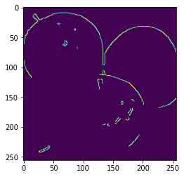

plt.imshow

(

img_edge

)

thresh, thresh_img = cv2.threshold(img, 200, 255, cv2.THRESH_BINARY)

plt.imshow(thresh_img)

<matplotlib.image.AxesImage at 0x7fda962ab910>

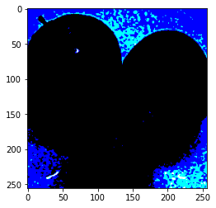

circle = cv2.circle(img,(300,200),60,(255,0,0),5)

plt.imshow(img)

<matplotlib.image.AxesImage at 0x7fda96021850>

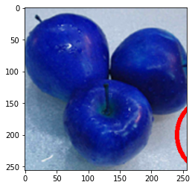

rectangle = cv2.rectangle(img,(200,100),(400,300),(0,0,255),10)

plt.imshow(img)

<matplotlib.image.AxesImage at 0x7fda95e23b50>

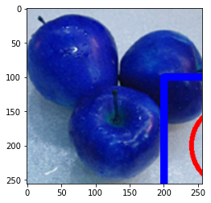

line = cv2.line(img,(200,100),(400,300),(0,255,0),3)

plt.imshow(img)

<matplotlib.image.AxesImage at 0x7fda95e15250>

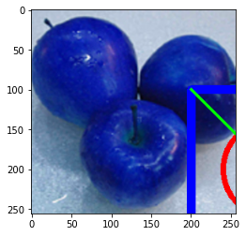

text = cv2.putText(img,"Opencv",(200,50),cv2.FONT_HERSHEY_SIMPLEX,2,(255,255,255),5)

plt.imshow(img)

<matplotlib.image.AxesImage at 0x7fda95d7a910>

